able of content
User Stories & Acceptance Criteria 2
System Architecture 5
GitHub Repository: sme-procurement-agent/ 8
AI Boundary Matrix: 9

User Stories & Acceptance Criteria
Here are the 12 user stories with detailed acceptance criteria, designed to be testable by the Quality/Security Lead.
1. Inventory Viewing
As a Procurement Officer, I want to view the current inventory levels of all items so that I can understand what stock is available.
- AC 1.1: Given I am on the inventory dashboard, when I load the page, then I see a list of all items with their current quantities.
- AC 1.2: Given I query "Show me inventory for dairy products," when I enter this phrase in the chat, then the system displays only dairy items with their quantities.
2. Low-Stock Flagging
As a Procurement Officer, I want the agent to automatically flag items that are below their reorder point, so I can prioritize what needs ordering.
- AC 2.1: Given a specific item's stock is below its defined reorder point, when the dashboard refreshes, then the item is highlighted in red.
- AC 2.2: Given I ask "What items are low on stock?", when the agent processes the query, then it returns a list of items with their current stock below the reorder point and a suggested quantity to order.
3. Quote Upload & Parsing
As a Procurement Officer, I want to upload a quote from a supplier and have the agent extract the key details, so I don't have to manually enter them.
- AC 3.1: Given I upload a well-formatted PDF quote, when the agent processes it, then it successfully extracts item names, unit prices, and total cost.
- AC 3.2: Given the quote is in an unreadable format (e.g., a scanned image without OCR), when the agent processes it, then it returns an error message indicating the format is unsupported.
4. Quote Comparison
As a Procurement Officer, I want to compare quotes from different suppliers side-by-side, so I can choose the best value option.
- AC 4.1: Given I have uploaded at least two quotes for the same item, when I ask "Compare quotes for Sugar," then the agent returns a table comparing prices and lead times.
- AC 4.2: Given I ask "What is the best offer for Sugar?", then the agent identifies the quote with the lowest total cost, considering delivery fees (if present).
5. Draft Requisition Generation
As a Procurement Officer, I want the agent to generate a structured draft purchase requisition based on low-stock items or my specific request, so I can send it for approval.
- AC 5.1: Given I select multiple low-stock items, when I click "Generate Draft Requisition," then the system creates a document with item names, quantities to order, and total estimated cost.
- AC 5.2: Given the requisition is generated, it must include a unique ID, the date, and the creator's name.
6. NL Historical Query
As a Procurement Officer, I want to ask questions about past sales data using natural language, so I can make informed ordering decisions.
- AC 6.1: Given I ask "How much cooking oil did we sell in the first week of November 2025?", when the agent processes the query, then it accurately returns the total quantity sold for that specific time period.
- AC 6.2: Given I ask a vague question like "Tell me about sales," then the agent will ask for clarification (e.g., "Which product or time period are you interested in?").
7. Trend-Based Reorder Estimation
As a Procurement Officer, I want the agent to suggest reorder quantities based on past sales trends, so I can minimize overstocking.
- AC 7.1: Given I ask "How much should I reorder for Sugar?", when the agent computes the suggestion, then it is based on the average sales of Sugar over the last 30 days.
- AC 7.2: The agent must provide a reasoning trail, e.g., "Based on your last 30 days of sales, you sold an average of 10 bags per day. I recommend ordering 100 bags to last 10 days."
8. Budget Range Estimation
As a Procurement Officer, I want the agent to estimate a rough budget range for a pending order, so I can check affordability before approval.
- AC 8.1: Given a draft requisition is being prepared, when I ask "What is the estimated budget?", then the agent provides a low and high estimate based on historical quote data.
9. Manual Override
As a Procurement Officer, I want to manually override a suggested quantity before the requisition is finalized.
- AC 9.1: Given the agent suggests ordering 100 units of Sugar, when I enter "Change Sugar quantity to 50," then the requisition quantity is updated to 50.
- AC 9.2: The system must log the override and the original suggestion.
10. Manager Approval
As a Shop Owner/Manager, I want to review and approve a draft requisition before any purchase is initiated.
- AC 10.1: Given a draft requisition is pending, when I log in, I see it under a "Pending Approval" tab.
- AC 10.2: Given I approve the requisition, when I click "Approve," the status changes to "Approved," and the audit log is updated.
- AC 10.3: Given I reject the requisition, when I click "Reject" and provide a reason, the status changes to "Rejected," and the procurement officer is notified.
11. Audit Lineage
As a Compliance Officer (or Developer), I want to see a full, auditable trail of every decision and action the agent takes.
- AC 11.1: Every user interaction (query, upload, approval) must be logged with a timestamp and user ID.
- AC 11.2: Every Agent decision (e.g., "Choose Supplier A because it was cheaper") must be logged in an execution trace.
- AC 11.3: All changes to a requisition (overrides, edits) must be logged.
12. Safety Guardrail
As a System User, I want the system to prevent an order that is more than 200% of the historical maximum for that item, preventing costly errors.
- AC 12.1: Given the historical max order for Sugar is 100 bags, when the agent or user attempts to set a quantity of 250 bags, the system will flag an error and prevent requisition creation until a manual override with a reason is entered.

System Architecture
The diagram illustrates a layered, bounded agentic system designed to streamline procurement preparation for Ugandan SMEs. The architecture emphasizes human oversight, safety guardrails, and a clear separation of responsibilities between AI-driven and deterministic components
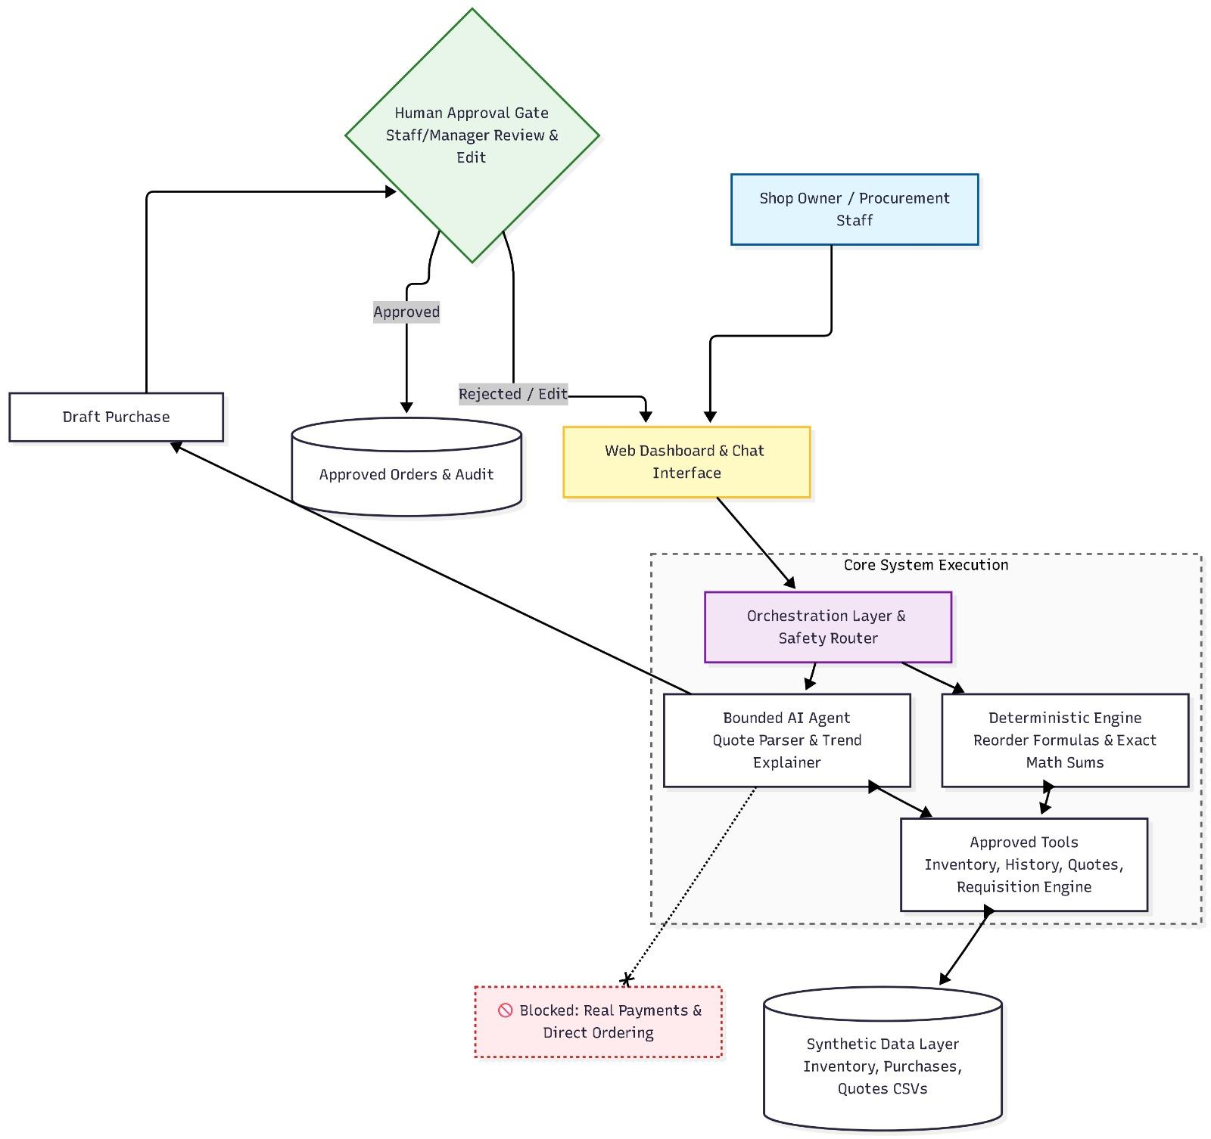
Description
1. User-Facing Layer (Top)
Web Dashboard & Chat Interface
- The primary interaction point for users (Procurement Officers and Shop Owners/Managers).
- Provides a web-based dashboard for viewing inventory, low-stock alerts, and requisition status.
- Includes a chat interface for natural language queries (e.g., "How much sugar did we sell last month?").
- All user inputs flow through this layer to the core system.
2. Human Approval Gate
Staff/Manager Review & Edit
- A mandatory human-in-the-loop checkpoint for all critical actions.
- Ensures that no order is placed without explicit managerial oversight.
- Allows managers to:
  - Review draft purchase requisitions.
  - Edit quantities or items before approval.
  - Reject or request modifications.
Approved / Rejected / Edit
- Represents the three possible outcomes of the review process:
  - Approved: Requisition moves to the audit log and becomes actionable.
  - Rejected: Requisition is returned to the procurement officer for revision.
  - Edit: Manager modifies the requisition before approval.
3. Core System Execution (Middle Layer)
This is the brain and engine of the system, where all processing happens. It is composed of several sub-components:
Component | Function
Orchestration Layer & Safety Router | The central traffic controller. Routes user requests to the appropriate subsystem (AI Agent, Deterministic Engine, or Tools). Enforces safety rules (e.g., quantity caps, permissions).
Bounded AI Agent | The intelligent reasoning engine. Uses a Large Language Model (LLM) to interpret user intent, plan actions, and generate natural language responses. Operates within strict boundaries—never allowed to execute payments or place orders autonomously.
Quote Parser & Trend Explainer | An AI-powered component that extracts structured data from unstructured supplier quotes (PDFs, emails, CSVs). Also generates natural-language explanations for trend-based reorder suggestions (e.g., "You sold 10 bags/day, so we recommend ordering 100").
Deterministic Engine | Handles all calculation tasks that require exact, verifiable logic. This includes:  • Reorder Formulas – calculating optimal order quantities.  • Exact Math Sums – adding costs, comparing prices, computing totals.  • Validation Rules – enforcing guardrails like the 200% cap.
Approved Tools | Pre-authorized function calls that the AI Agent can invoke. Examples:  • query_inventory() – fetch stock levels.  • compare_quotes() – rank supplier offers.  • generate_requisition() – produce a draft purchase order.
4. Data Foundation Layer (Bottom)
Synthetic Data Layer
- The system runs on synthetic data during development and testing phases.
- Composed of structured CSV files representing:
  - Inventory – current stock levels, reorder points, historical max quantities.
  - Purchases – past purchase orders, dates, suppliers.
  - Quotes – historical supplier quotes (prices, lead times, quality ratings).
- This data powers both the Deterministic Engine (calculations) and the RAG (Retrieval-Augmented Generation) component for the AI Agent.
5. Critical Boundary Stop (Bottom-Right)
Blocked: Real Payments & Direct Ordering
- Explicitly marked as out-of-scope.
- The system does not connect to:
  - Payment gateways (e.g., mobile money, bank APIs).
  - Supplier ordering APIs.
  - Any system that could execute a financial transaction.
- This boundary ensures the agent remains bounded and safe, requiring a human to complete the final step of procurement.

GitHub Repository: sme-procurement-agent/
📂 .github/workflows/ → CI/CD pipelines (future)
📂 docs/ → All documentation
- project-charter.md – Problem, scope, value proposition
- user-stories.md – 12 stories with AC (Quality Lead)
- ai-boundary-matrix.md – AI vs. deterministic vs. human
- architecture.md – System diagrams
📂 src/ → All source code
- agent/ – Core Agent logic (Sense → Plan → Act)
- tools/ – Function definitions (e.g., compare_quotes())
- rag/ – Retrieval & indexing components
- data/ – Synthetic data generator & CSVs
- utils/ – Helpers (file parsing, logging) (Quality Lead)
📂 tests/ → All test suites (Quality Lead)
- unit/ – Unit tests for deterministic functions
- integration/ – End-to-end agent flow tests
- eval/ – 30+ evaluation scenarios (Week 7)
📄 Config Files:
- .gitignore – Git exclusions
- README.md – Project overview
- requirements.txt – Python dependencies
- prompt_spec.md – Week 2 prompt spec

AI Boundary Matrix:

Function | AI Does This | Code/System Does This | Human Does This
Inventory  Viewing | Translates  NL to SQL | Executes  query, formats results | —
Low-Stock  Flagging | Suggests  optimal reorder qty. | Compares  stock vs. reorder point | —
Quote  Upload & Parsing | Extracts  structured data | Validates  extracted format | —
Quote  Comparison | Summarizes  options | Calculates  total cost (price + delivery) | —
Draft  Requisition | Assembles  data into document | Generates  ID & timestamp | Approves final version
NL  Historical Query | Translates  NL to query | Executes  precise time-based queries | —
Trend-Based  Reordering | Infers  demand patterns | Calculates  statistical averages | —
Budget  Estimation | Retrieves  historical data | Performs  arithmetic (±10% range) | —
Manual  Override | — | Updates  database & logs change | Override reason required
Manager  Approval | — | Routes  request to manager | Final Approver
Audit  Lineage | Logs  reasoning steps | Logs  deterministic actions | —
Safety  Guardrail | — | Enforces  200% hard cap | Override approval required

